Kilkenny County Council's Management Structure is:

 | Lar Power  Chief Executive  056-7794075  lar.power@kilkennycoco.ie | Chief Executive of  Kilkenny County Council
 | Mary J. Mulholland  Director of Services  056-7794900  mary.mulholland@kilkennycoco.ie | Director of Services with responsibilities for:  Housing, Community, Library, Arts & Heritage.
 | Tim Butler  Director of Services  056-7794070  tim.butler@kilkennycoco.ie | Director of Services with responsibilities for:  Corporate, Human Resources, Roads & Transportation, Water Services, Communication, Health & Safety  Municipal District of Kilkenny
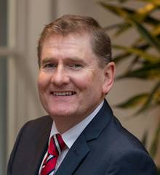 | Sean McKeown  Director of Services  056-77940082  sean.mckeown@kilkennycoco.ie | Director of Services with responsibilities for:  Planning, Environment, Building Control, Parks, LEO/Economic Development, Tourism Marketing & Veterinary Services  Municipal District of Piltown
 | Martin Prendiville  Head of Finance  056-7794214  martin.prendiville@kilkennycoco.ie | Director of Services for responsibilities for:  Finance, Information Technology, Facilities Management, Procurement & Special Projects  Municipal District of Castlecomer
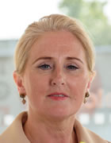 | Fiona Deegan  Acting Director of Services  056-7794196  fiona.deegan@kilkennycoco.ie | Director of Services for responsibilities for:  Management of Ukrainian Response Unit & Fire Services  Municipal District of Callan/Thomastown

